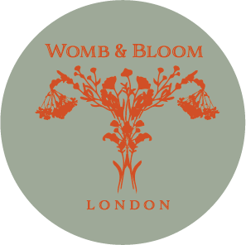
Womb & Bloom Access Fund Application
What is the Access Fund?
The Womb & Bloom Access Fund was established in 2022 to help make our services more accessible to women and birthing people who may otherwise be unable to afford them.
The fund has grown through the generosity and collaboration of our collective. Contributions from practitioners, bookings, courses, gatherings, and classes are reinvested into the fund. We have also received generous donations from clients who have used our services, as well as fundraising by Victoria and her family, including half-marathon events.
Am I eligible?
You may be eligible if:
- Your individual household income is below £20,000, or
- Your combined household income is below £38,000
And you:
- Live in social housing, or
- Are living under an official affordable-rent or charitable housing scheme.
If you believe you meet these criteria, please complete the application form below and email it to theteam@wombandbloom.co.uk.
What can the Access Fund be used for?
Funding may contribute towards:
- Antenatal or postnatal specialist support
- Womb & Bloom courses
- Independent midwifery care packages
- Antenatal, birth or postnatal doula support
How does the Access Fund work?
The amount available will always be discussed and confirmed with you before any booking or financial commitment is made. Your practitioner will discuss their fees and available options with you, including an open conversation about what you may be able to contribute towards the cost of your chosen service, so we can work together to support your wishes wherever possible.

